Basics of Port Addressing

Analogy: Someone sends you a gift from a different country.

Reaching our city = Reaching our network (IP Address)

Reaching our apartment = REaching the host (MAC Address)

Reaching the right person = Reaching the right process (Port address)

Port Address / Port Number

1. In a node, many processes will be running
2. Data which are sent/received must reach the right process.
3. Every process in a node is uniquely identified using port numbers
4. Port = Communication endpoint
5. Fixed port numbers and dynamic port numbers(0-65535)
6. Example:
   1. Fixed port number: 25,80 etc,
   2. OS assigned dynamic port numbers: 62414

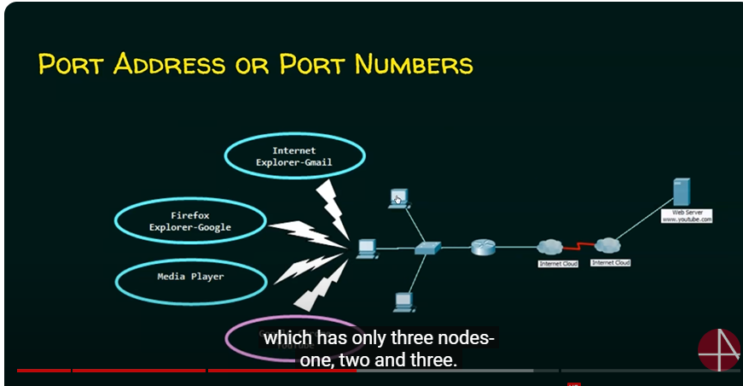

When computer send data for youtube it puts the source port number and destination port number.

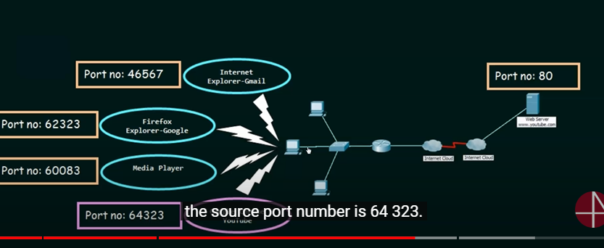

Source number: 64323

How to see port numbers in real systems?

Resource monitor.

3 key points to ponder

Before sending the data, any node must:

1. Attach source IP address and destination IP address (Network is getting identified)
2. Attach source MAC address and destination MAC address ( Right host is identified)
3. Attach source port number and destination port number. ( Right process of that host is identified)